Cyber Security Controls in Nuclear Power Plant
by Technical Assessment Methodology

ABSTRACT :-

With the rapid increase in cyber attacks on industrial control systems, the significance of the application of cyber security controls and the evaluation of security against such attacks has also increased. Among them, cyber attacks on nuclear power plants (NPPs) can cause not only economic loss, but also human casualties. Thus, the application of cyber security controls is necessary for mitigating security threats, especially to NPPs. However, currently, there are limited resources pertaining to information protection, which is essential to uniformly deploy all the controls required to meet cyber security regulations. To overcome this challenge, effective cyber security controls need to be identified and adequate information protection resources must be allocated to each NPP. Although NPPs apply a differential security control according to its characteristics based on NEI 13-10 (Cyber Security Control Assessments), this alone is not only insufficient in reflecting the latest security threats, but also fails to confirm whether the security controls have actually mitigated such threats. To address this challenge, the Electric Power Research Institute (ETRI) developed the technical assessment methodology (TAM), which can be used to generate a quantitative score by assessing the effects of potential cyber attacks on an asset and the relevant security controls. This methodology allows for the application of differential security control based on the score to identify whether the security controls have actually mitigated the risks. Considering this context, the purpose of this paper is to conduct a comparative analysis of the results derived from applying security controls and assessing risks using only NEI 13-10 as well as both NEI 13-10 and TAM on the plant protection system of the nuclear power reactor APR1400. Furthermore, this paper discusses the scopes for subsequent research by addressing the limitations of the TAM and considerations for its use.

Existing System:-

Industrial control systems, such as nuclear power plants (NPPs), are increasingly exposed to cyber threats that can lead to serious economic losses and even human fatalities. NPPs, in turn, historically adopt differential application of cybersecurity controls depending on NEI 13-10 (Cyber Security Control Assessments). As much as NEI 13-10 offers a formalized method for applying controls based on plant-specific attributes, it has significant limitations. In particular, it fails to ensure sufficient consideration of new and developing cyber threats and also lacks a means of quantitatively confirming whether the implemented controls reduce the risks sufficiently. Additionally, due to limited protection resources for information, it is generally difficult to implement all required controls uniformly across all NPP assets.

Disadvantages of the Existing System:-

- NEI 13-10 fails to exhibit current and state-of-the-art cyber threats.

- Lack of quantitative confirmation of whether implemented controls reduce risks.

- Dependent on static, differential application of controls that can ignore changing vulnerabilities.

- Insufficient information protection resources to deploy all control requirements uniformly.

- Ineffective allocation of security measures among critical NPP assets.

Proposed System:-

As a solution for these limitations, the Technical Assessment Methodology (TAM) proposed by the Electric Power Research Institute (ETRI) is presented. TAM facilitates quantitative assessment of cybersecurity through the production of a score that indicates the performance of security controls against possible cyber-attacks on identified NPP assets. Through the integration of NEI 13-10 and TAM, differential controls can be implemented more efficiently so that limited resources will be assigned to the most important areas. In contrast to the conventional methods, this combined approach confirms if security controls indeed reduce risks and is data-driven for ongoing improvement. In the example of the APR1400 reactor plant protection system, this comparative analysis proved that the integration of NEI 13-10 with TAM results in more accurate and effective risk reduction than using NEI 13-10.

Benefits of the Proposed System:-

- Offers a quantitative scoring system to quantify control effectiveness.

- Improves NEI 13-10 by taking into account changing and sophisticated cyber threats.

- Facilitates evidence-based decision-making in allocating resources.

- Verifies if implemented controls indeed reduce risks.

- Enables customized and effective deployment of cybersecurity controls on NPP assets.

- Enhances resilience of important plant systems (e.g., APR1400 plant protection system).

SYSTEM REQUIREMENTS:

HARDWARE REQUIREMENTS:

• System : Pentium IV 2.4 GHz.
• Hard Disk : 40 GB.
• Ram : 512 Mb.

SOFTWARE REQUIREMENTS:

• Operating system : - Windows.
• Coding Language : python.

SYSTEM ARCHITECHTURE:-
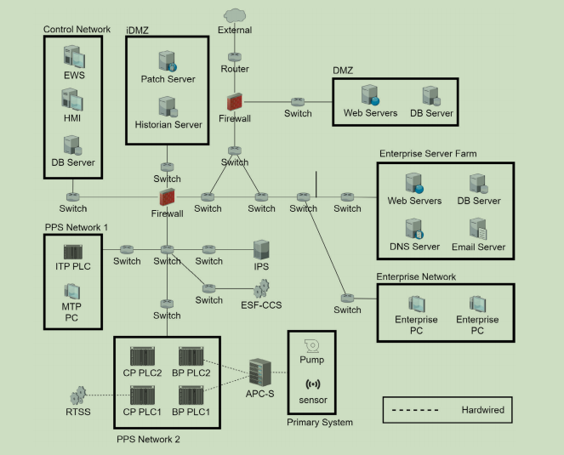

Module Description:-

1. Cyber Security Control Identification Module
This module identifies the necessary cyber security controls required to protect Nuclear Power Plant (NPP) systems from cyber attacks. It analyzes regulatory standards and guidelines such as NEI 13-10 to determine appropriate security measures for critical plant components.
2. Threat and Risk Analysis Module
This module analyzes potential cyber threats and vulnerabilities that may affect the nuclear power plant systems. It evaluates possible attack scenarios and their impact on plant operations, safety systems, and critical infrastructure.
3. Technical Assessment Methodology (TAM) Evaluation Module
This module applies the Technical Assessment Methodology (TAM) to evaluate the effectiveness of implemented security controls. It calculates a quantitative risk score by assessing how potential cyber attacks could impact plant assets and how well existing controls mitigate those risks.
4. Security Control Implementation Module
This module helps deploy appropriate cyber security controls based on the risk scores generated by the assessment process. It supports differential security control implementation to ensure that high-risk systems receive stronger protection measures.
5. Comparative Analysis Module
This module compares the effectiveness of security assessments performed using only NEI 13-10 and those using both NEI 13-10 and TAM. The comparison helps determine whether additional methodologies improve risk mitigation and cyber defense.
6. Resource Allocation and Protection Module
This module helps allocate limited information protection resources effectively across different systems in the nuclear power plant. It ensures that critical assets receive adequate security coverage based on risk priority.
7. Reporting and Decision Support Module
This module generates detailed reports on risk assessments, security control effectiveness, and system vulnerabilities. These reports assist security analysts and plant operators in making informed decisions to strengthen cyber security in nuclear power plants.

Functional Requirements
User Functional Requirements
- User Authentication and Access
  - The user shall be able to securely log in to the system using authorized credentials.
  - The system shall provide role-based access to view cybersecurity assessment data.
- Threat and Risk Monitoring
  - The user shall be able to view identified cyber threats and vulnerabilities affecting Nuclear Power Plant (NPP) systems.
  - The system shall display the potential impact of attacks on plant operations and safety systems.
- Risk Score and Assessment Viewing
  - The user shall be able to view quantitative risk scores generated by the Technical Assessment Methodology (TAM).
  - The system shall present risk levels for different plant assets and control systems.
- Security Control Status Viewing
  - The user shall be able to view implemented cyber security controls based on standards such as NEI 13-10.
  - The system shall show how these controls mitigate specific threats.
- Report Generation and Analysis
  - The user shall be able to generate and view reports on cyber security risks and mitigation effectiveness.
  - The system shall provide insights to support operational and security decision-making.

Admin Functional Requirements
- Admin Authentication and User Management
  - The admin shall securely log in to access administrative functions.
  - The admin shall manage user accounts, roles, and access permissions.
- Cyber Security Control Configuration
  - The admin shall configure and update cyber security controls based on regulatory standards such as NEI 13-10.
  - The admin shall manage security policies and system protection settings.
- Risk Assessment Management
  - The admin shall run and manage Technical Assessment Methodology (TAM) evaluations for plant assets.
  - The admin shall update risk parameters and assessment criteria.
- Resource Allocation Management
  - The admin shall allocate information protection resources to critical systems based on risk scores.
  - The admin shall prioritize high-risk assets for stronger security control implementation.
- System Monitoring and Reporting
  - The admin shall monitor system-wide cybersecurity performance and vulnerability status.
  - The admin shall generate detailed analytical reports for regulatory compliance and security improvement.

